ISP
vim /etc/sysconfig/network – меняем hostname на ISP
vim /etc/hostname – меняем имя на ISP
reboot
Запускаем rtr-ы
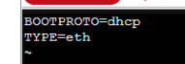
ISP
vim /etc/net/ifaces/ens18/options –
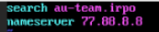
vim /etc/net/ifaces/ens18/resolv.conf
mkdir /etc/net/ifaces/ens19
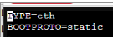
vim /etc/net/ifaces/ens19/ipv4address –
vim /etc/net/ifaces/ens19/options -
mkdir /etc/net/ifaces/ens20

vim /etc/net/ifaces/ens20/ipv4address -
vim /etc/net/ifaces/ens20/options -
vim etc/net/sysctl.conf -
systemct restart network (service network restart)
apt-get update
apt-get install iptables –y
iptables –t nat –A POSTROUTING –o ens18 –j MASQUERADE
iptables-save >> /etc/sysconfig /iptables
systemctl enable --now iptables
systemctl restart network
iptables –t nat –L –n –v – проверка наличия правил
reboot

Переходим к настройке Hq-rtr
hostname hq-rtr.au-team.irpo
do show port brief (первый порт идет в сторону isp)
int ISP
ip address 172.16.4.2/28
ex
port te0
servise-instance te0/ISP
encapsulation untagged
connect ip interface ISP
int vl100
ip address 172.17.250.65/26
int vl200
ip address 172.17.250.161/28
int vl999
ip address 172.17.250.177/29
port te1
service-instance te1/vl100
encapsulation dot1q vl100
rewrite pop 1
connect ip int vl100
ex
service-instance te1/vl200
encapsulation dot1q vl200
rewrite pop 1
connect ip int vl200
ex
service-instance te1/vl999
encapsulation dot1q vl999
rewrite pop 1
connect ip int vl999
ex
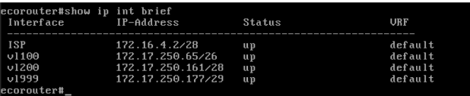
ex
ip route 0.0.0.0/0 172.16.4.1
ip name-server 77.88.8.8
show ip int brief – должно быть так
так же стоит проверить ping isp-rtr
wr memory
Переходим к настройке Br-rtr
hostname br-rtr.au-team.irpo
int ISP
ip address 172.16.5.2/28
ex
port te0
servise-instance te0/ISP
encapsulation untagged
connect ip interface ISP
ex
ex
int vl100
ip address 172.17.250.129/27
ex
port te1
service-instance te1/vl100
encapsulation dot1q vl100
rewrite pop 1
connect ip int vl100
ip route 0.0.0.0/0 172.16.5.1
ip name-server 77.88.8.8
show ip int brief
так же стоит проверить ping isp-rtr
wr memory

Hq-srv
vim /etc/net/ifaces/ens18/ipv4address – 172.17.250.66/26
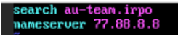
vim /etc/net/ifaces/ ens18/ipv4route - default via 172.17.250.65
vim /etc/net/ifaces/ens18/resolv.conf
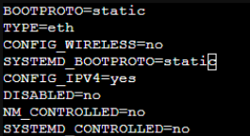
vim /etc/net/ifaces/ens18/options
systemctl restart network
hostname hq-srv
useradd sshuser –u 1010
passwd sshuser
P@ssw0rd (два раза)
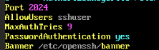
gpasswd –a sshuser wheel
vim/etc/openssh/sshd_config
vim /etc/openssh/banner
systemctl restart sshd
ssh –p 2024 localhost
ssh –p 2024 sshuser@localhost
(для обоих серверов) vim /etc/apt/apt.conf
Br-srv
vim /etc/net/ifaces/ens18/ipv4address – 172.17.250.130/27

vim /etc/net/ifaces/ens18/ipv4route - default via 172.17.250.129
vim /etc/net/ifaces/ens18/resolv.conf

vim /etc/net/ifaces/ens18/options
systemctl restart network
hostname br-srv
useradd sshuser –u 1010
passwd sshuser

P@ssw0rd (два раза)
gpasswd –a sshuser wheel
vim /etc/openssh/sshd_config
vim /etc/openssh/banner
systemctl restart sshd
ssh –p 2024 localhost
ssh –p 2024 sshuser@localhost
hq-rtr/br-rtr (одинаковые команды)
en
conf t
username net_admin
password P@ssw0rd
role admin
wr memory
show users localdb
hq-rtr
interface tunnel.0
ip address 10.10.10.1/30
ip tunnel 172.16.4.2 172.16.5.2 mode gre
wr memory
show int tunnel.0
bt-rtr
interface tunnel.0
ip address 10.10.10.2/30
ip tunnel 172.16.5.2 172.16.4.2 mode gre
wr memory
show int tunnel.0
hq-rtr
en/conf t
router ospf 1
passive-interface default
no passive-interface tunnel.0
network 10.10.10.0/30 area 0
network 172.17.250.64/26 area 0
network 172.17.250.160/28 area 0
network 172.17.250.176/29 area 0
area 0 authentication
ex
int tunnel.0
ip ospf authentication-key P@ssw0rd
ex
wr memory
show ip ospf neighbor/show ip route ospf – для проверки
br-rtr
en/conf t
router ospf 1
passive-interface default
no passive-interface tunnel.0
network 10.10.10.0/30 area 0
network 172.17.250.128/27 area 0
area 0 authentication
ex
int tunnel.0
ip ospf authentication-key P@ssw0rd
ex
wr memory
show ip ospf neighbor/show ip route ospf – для проверки
после надо пропинговать сервера друг с другом
hq-rtr
en/conf t
int ISP
ip nat outside
int vl100
ip nat inside
int vl200
ip nat inside
int vl999
ip nat inside
ip nat pool HQ 172.17.250.65-172.17.250.254
ip nat source dynamic inside-to-outside pool HQ overload interface ISP
wr memory
br-rtr
en/conf t
int ISP
ip nat outside
int vl100
ip nat inside
ip nat pool BR 172.17.250.129-172.17.250.254
ip nat source dynamic inside-to-outside pool BR overload interface ISP
пингуем сервера с ISP
show ip nat translations
пробуем прописать apt-get update на серверах
wr memory
hq-rtr
en/conf t
ip pool HQ-clients 172.17.250.162-172.250.174
dhcp-server
pool HQ-clients 1
mask 255.255.255.240
gateway 172.17.250.161
dns 172.17.250.66
domain-name au-team.irpo
ex
ex
int vl200
dhcp-server 1
ex
wr memory
show dhcp-server 1 detailed
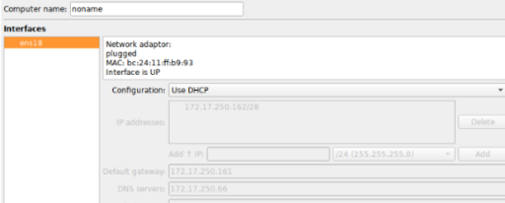
show dhcp-server clients vl200 (после получения ip на hq-cli)
hq-cli
заходим в машину, используем dhcp

hq-srv
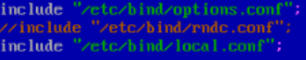
apt-get update && apt-get install bind –y
cd /etc/bind
mcedit named.conf – комментируем вторую строку
mcedit options.conf (следующие параметры нужно изменить):
listen-on { 172.17.250.66; };
//listen-on-v6 { ::1; };
forwarders { 77.88.8.8; };
allow-query { any; }
allow-query-cache { any; }
allow-recursion { any; }
mcedit local.conf
zone “au-team.irpo”{
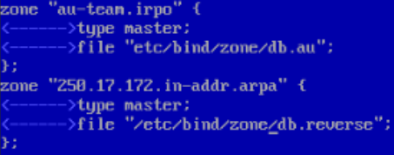
type master;
file “etc/bind/zone/db.au”;
};
zone “250.17.172.in-addr.arpa” {
type master;
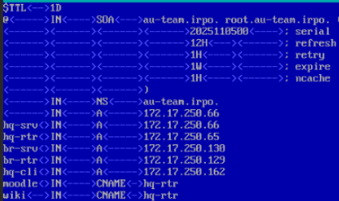
file “etc/bind/zone/db.reverse”;
};
cd zone
ls
cp localhost db.au
mcedit db.au
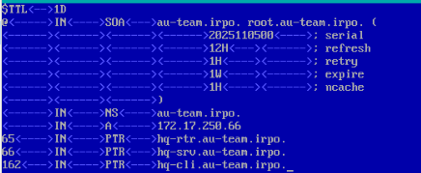
cp db.au db.reverse
chown root:named db.*
mcedit db.reverse

named-checkzone au-team.irpo db.au
named-checkzone 250.17.172.in-addr.arpa db.reverse
sustemctl restart bind

cd /etc/net/ifaces/ens18/
mcedit resolv.conf
systemctl restart network
systemctl restart bind
host hq-srv
Hq-rtr/br-rtr
en/conf t
ip name-server 172.17.250.66
ip domain-name au-team.irpo
ip domain-lookup
no ip name-server 77.88.8.8 (если есть в sh run)
do ping hq-srv
wr memory
Br-srv hq-cli

Нужно зайти в resolv.conf
vim /etc/net/ifaces/ens18/resolv.conf - делаем так же

hq-cli/hq-srv/br-srv/ISP
timedatectl set-timezone Europe/Moscow
timedatectl
Hq-rtr/br-rtr
ntp timezone utc+3
show ntp timezone

